The Chinese University of Hong Kong
Faculty of Engineering 20th Anniversary Celebration
Alumni Reunion Dinner
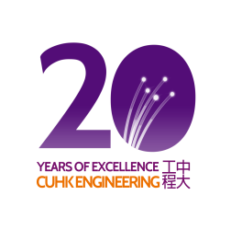


Date：18 September, 2011 (Sun)
Time：6:00-9:30pm Fee：HKD250/seat
*Special Offer: $100 deduction for application in group of 4 (ie. $900/4 seats)
Venue：Chung Chi College Staff Club, CUHK
www.erg.cuhk.edu.hk/20th_Anniversary/alumni.htm
All engineering alumni and friends are welcome!

Department | Contact Person | Email | Tel
Computer Science and Engineering | Derek Ngai | derek@mac3mac4.com | 9211 5271
Electronic Engineering | Lau Hung Cheong | hclau@fit.com.hk | 9280 9863
Information Engineering | Kelvin Chan | spring828hk@gmail.com | 6159 7787
Mechanical and Automation Engineering | Alan Lam | alan@sengital.com | 9721 0167
Systems Engineering and Engineering Management | Liliana Lau | cuhksealumni@gmail.com | 9760 3454

- - - - - - - - - - - - - - - - - - - - - - - - - - - - - - - - - - - - - - - - - - - - - - - - - - - -
Registration Form
Please transfer payment to following account via ATM, e-bank or direct debit and keep a copy of payment receipt. Then send a completed registration form along with the payment receipt to erg20ReunionDinner@cuhkeeaa.org on or before 13 September 2011 (Tue). All registration will be confirmed by email not later than 14 September 2011.
For enquiries, please contact corresponding contact person. Thank you

Payable to: Electronic Engineering Alumni Association The Chinese University of Hong Kong
Account No.: 004-126-512391-001

 | I and family members totaling |  |  |  | Adults and |  | Children will attend the Engineering
 | Alumni Reunion Dinner in celebration of the Faculty 20th Anniversary.
 | Name | :
 | Telephone | :
 | Email | :
 | Graduated Dept. & Year | :
 | Signature | :
 | Date | :

